Experiment 2

**AIM:** To create a LAMP instance in the AWS CLI.

RA2011028010078

Shantanu Sahay

**PROCEDURE:**

1. Firstly, type sudo su to become the root user.
2. To update all the packages in your instance type “yum update -y”.

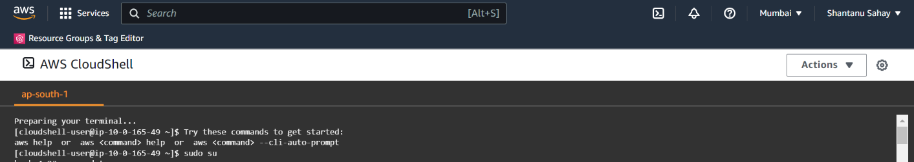

1. To install Apache server in linux, type “yum install httpd

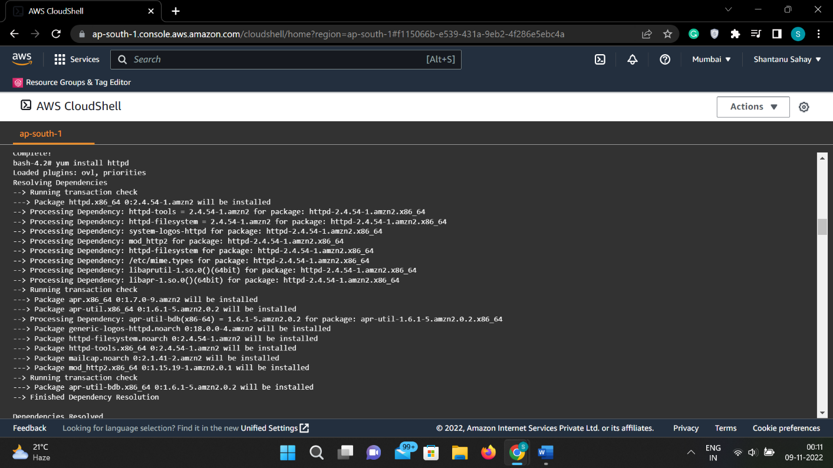

1. To install mysql or mariadb type “yum install mariadb mariadb-server”.

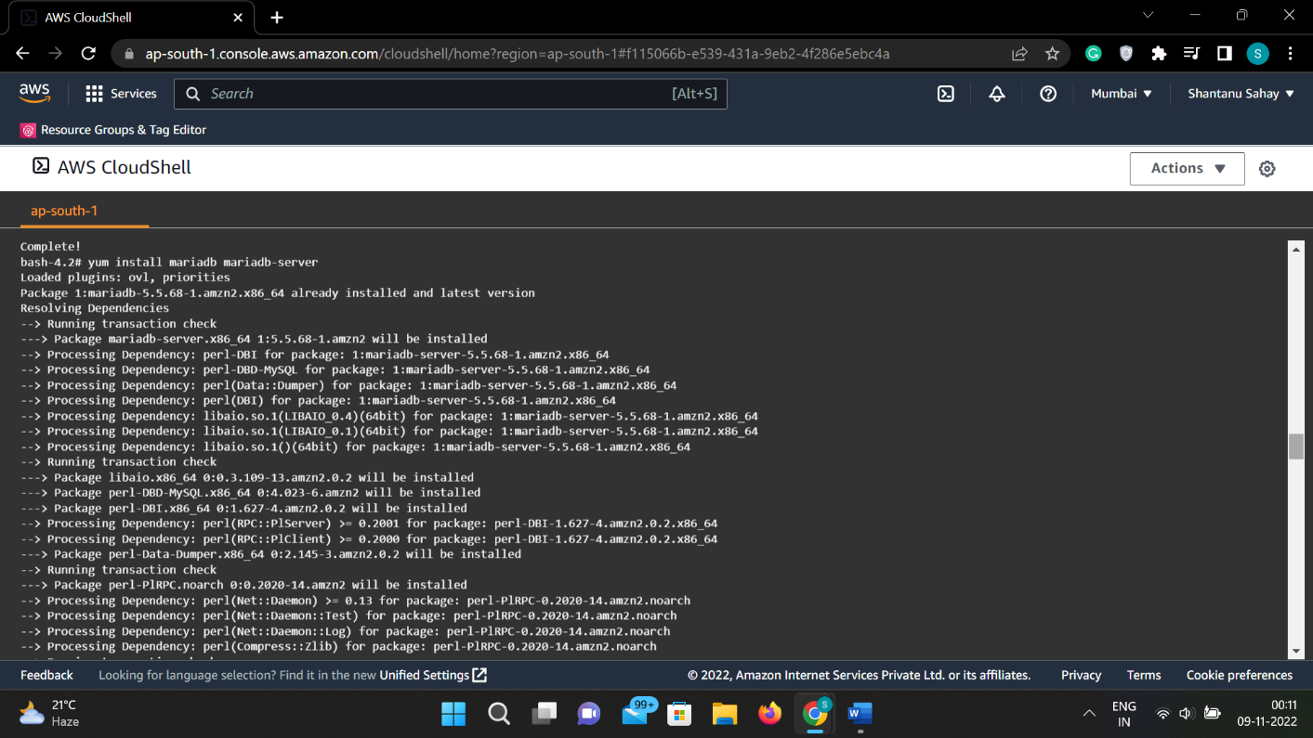

1. To install php, type “yum install php php-mysql”.

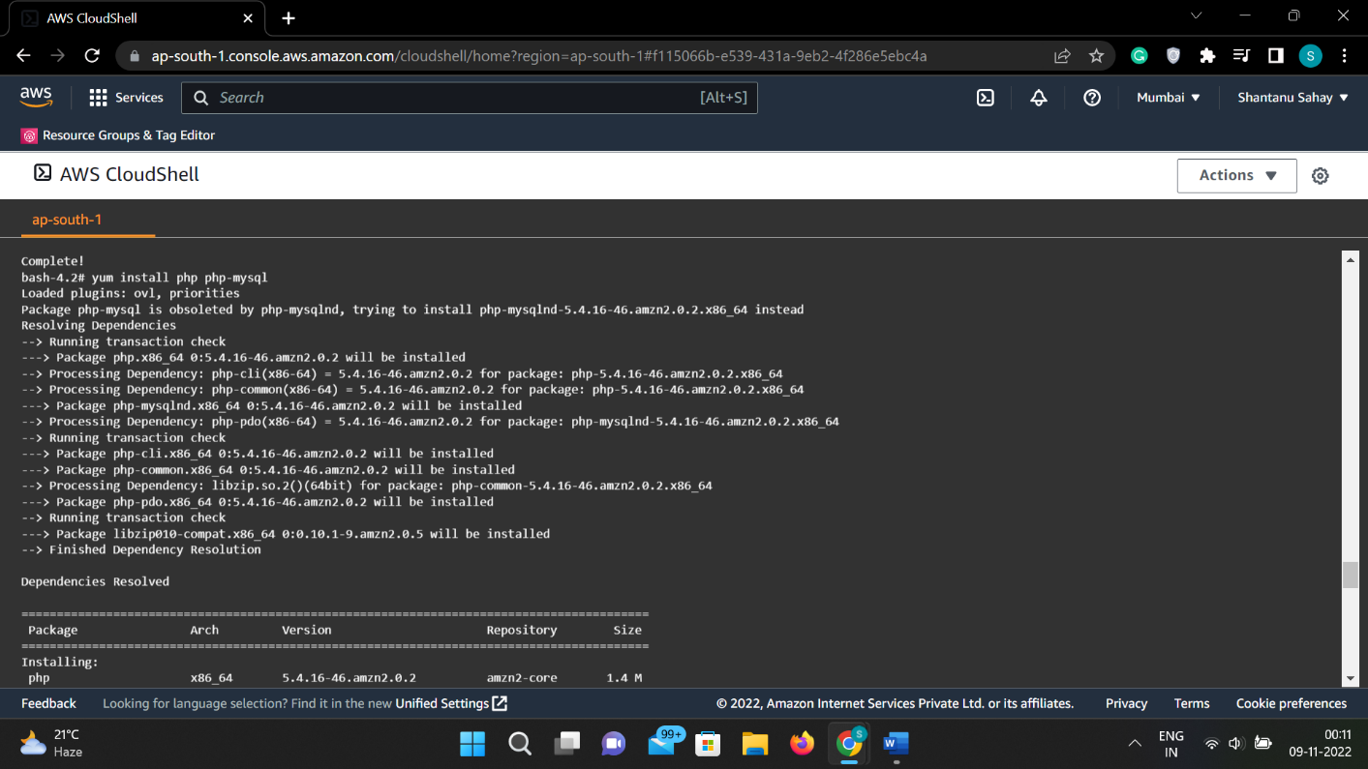

1. Type “yum search php” to see all the packages installed in the server.

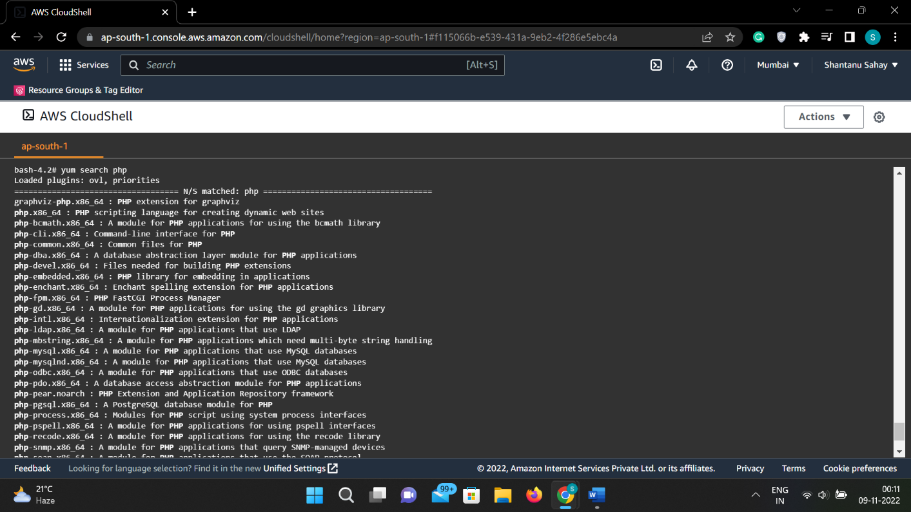

1. Enabling the mariadb server.

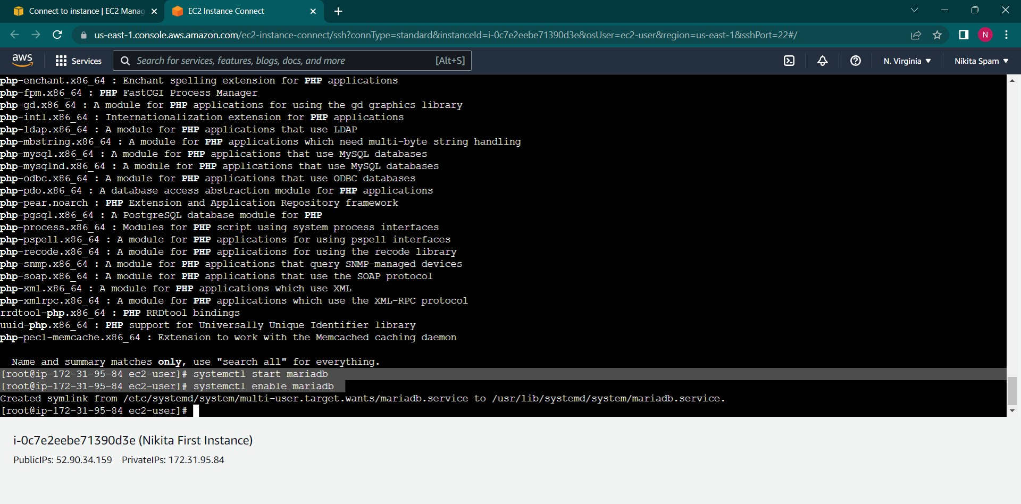

1. After enabling httpd (apache server) , go to the directory where cd

/var/www/html/

1. Go to vim and type “vim index.php”.

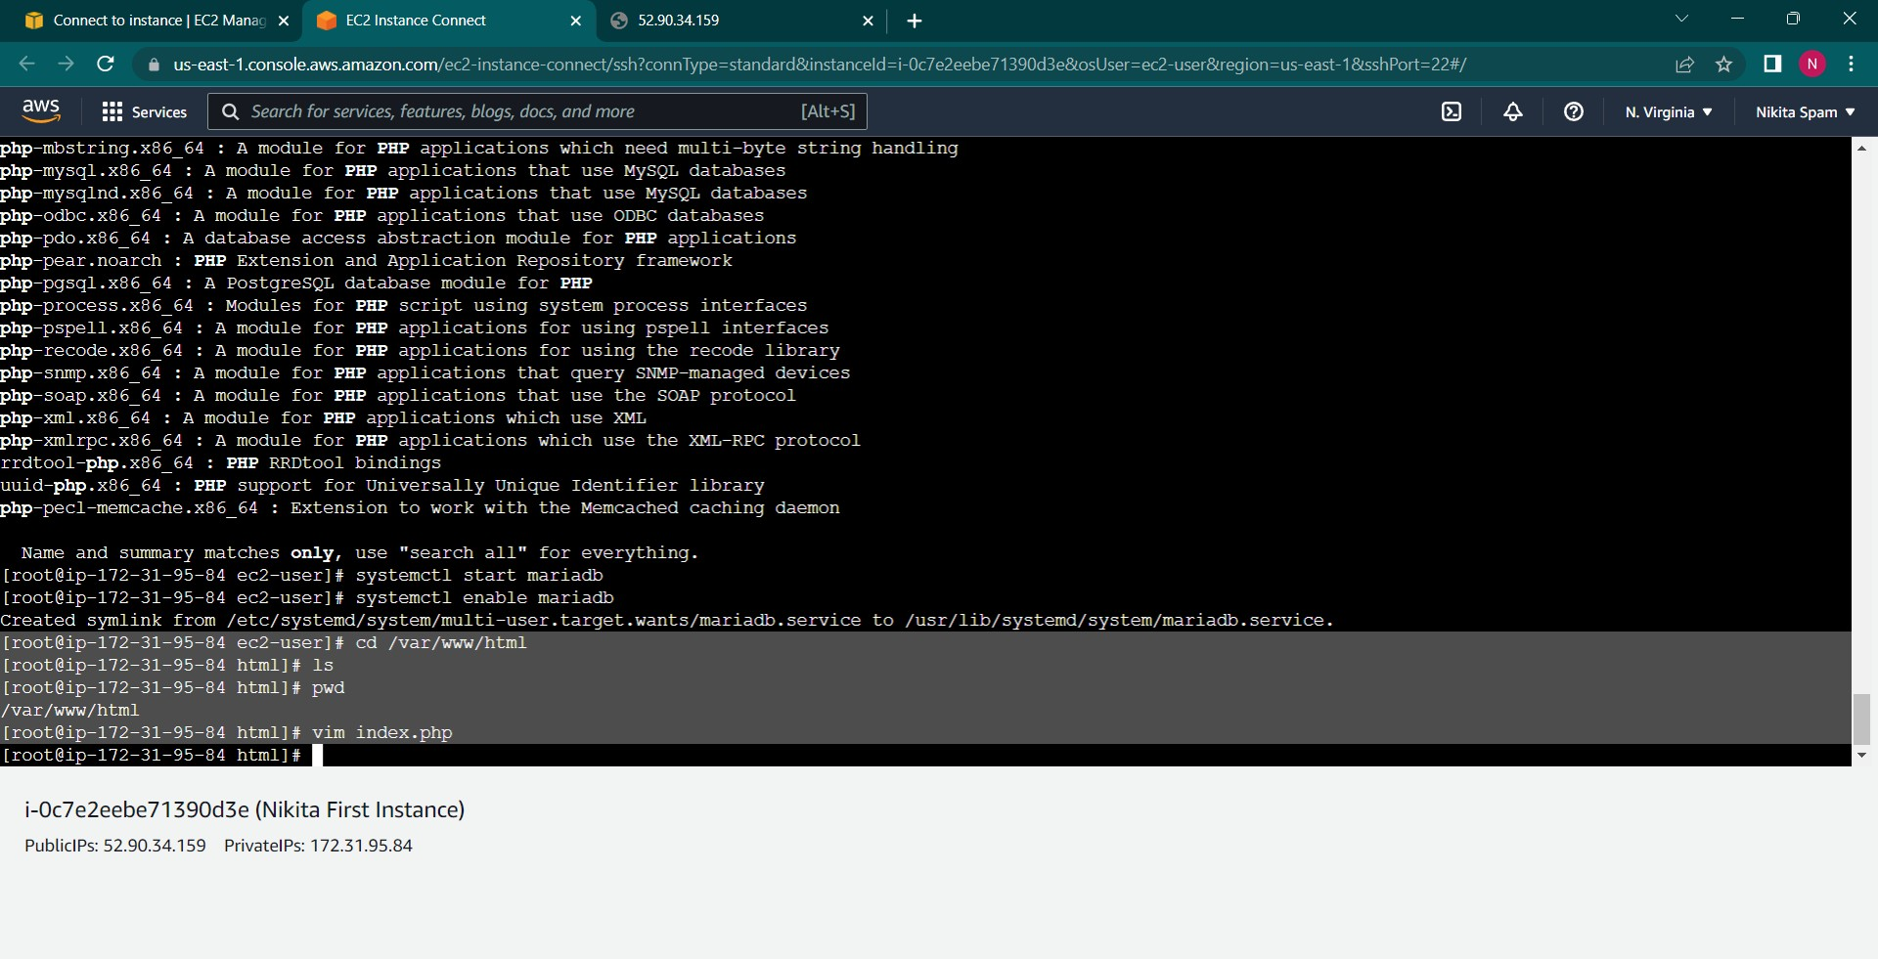

**Output:**

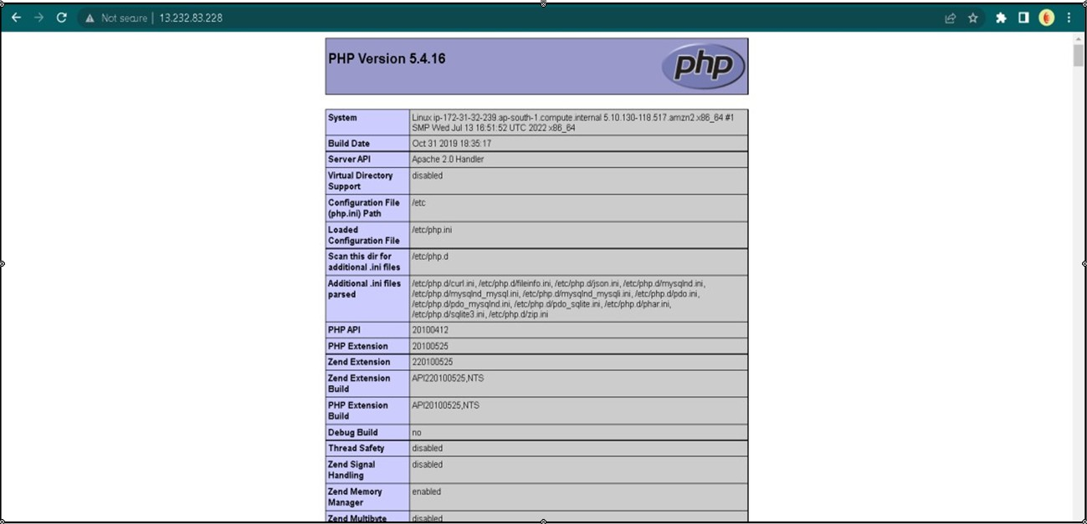

**RESULT:** LAMP instance was successfully created and executed in AWS CLI.